**Wellness Tracker - Rocco Ricciardi & Kareem Fayek**

This app is a Health and Wellness tracker. The user logs their daily meals and drinks in the app which is reflected in the “Piggy” on the main screen. If the user is eating healthily then the Piggy will appear healthy. However, if the user’s inputs indicate that he or she is not being healthy, it will also be reflected in the Piggy’s appearance (dehydrated, hungry, overeating, etc).

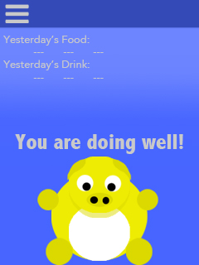 Homescreen

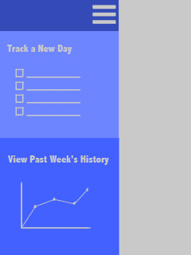 Menu

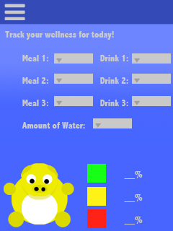 Track a New Day

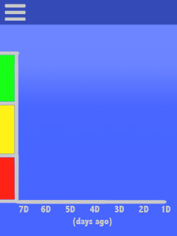 History